**Supporting information**

**Part 1: Principle of TV**

The principle of TV is that restore the pending region in pixels through the information of the boundary pixels from the outside of marked region. The mathematical formula of TV model is Eq. (A.1):

 （A.1）

Among the expression, E is represented the marked pending region and D is represented the other region and u is represented the pixel value in the pending region. If u0 is defined as the original pixel and u is defined as the restored pixel, the expression of u is Eq. (A.2):

 （A.2）

**Part 2: Principle of Criminisi**

The principle of Criminisi is that chose one pixel (denoted by p) which has the highest confidence weight (Eq. (A.3)) among the boundary of pending area, and chose the area of specified size (9*9 in this article) around p as a template. Then find the best-matched (SSD standard, Eq. (A.4)) area in unbroken region to replace the template area, and meanwhile update the confidence weight of p. By parity of reasoning, repeat the preceding procedure and the pending area will be restored after the end of the iteration.

 （A.3）

 （A.4）

**part 3: Some samples in the restoration algorithm test experiment**

（1）samples of long stripe restoration

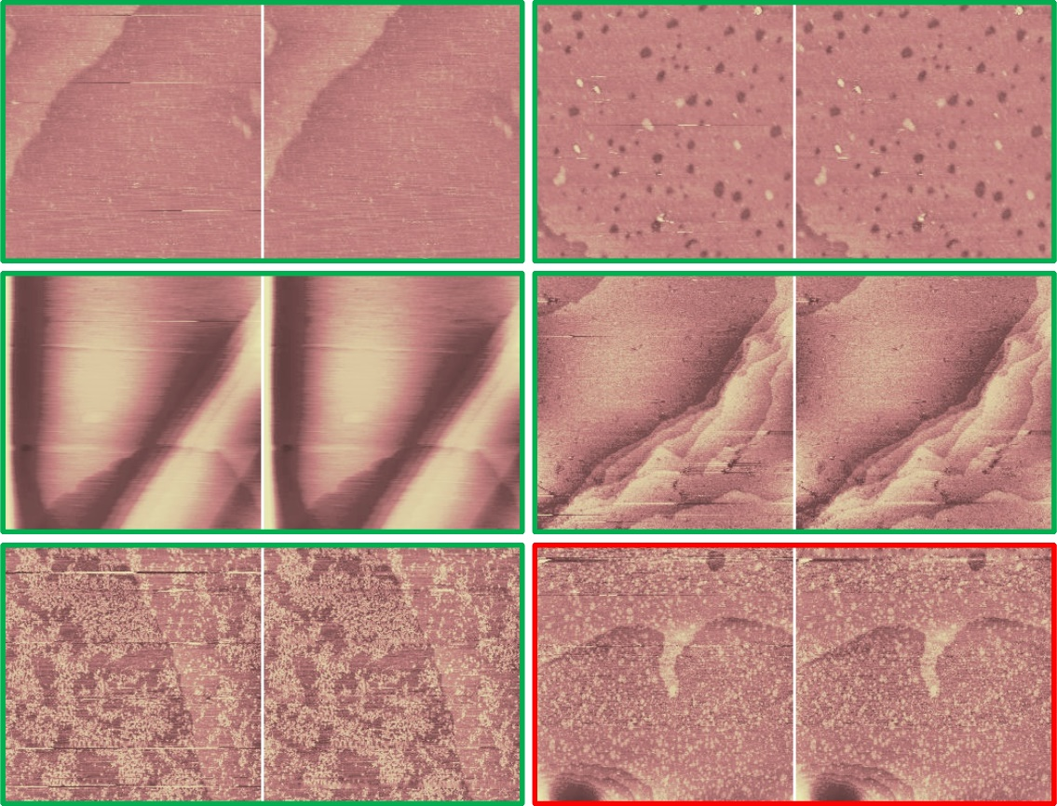

Figure (A.1): samples in the long stripe restoration test experiment, the green border represents the restoration is good (defects are restored visually well with little residue and pseudo stripe), the red border represents the restoration is bad (defects partly remain or some side effects are introduced).

(2) samples of short stripe restoration

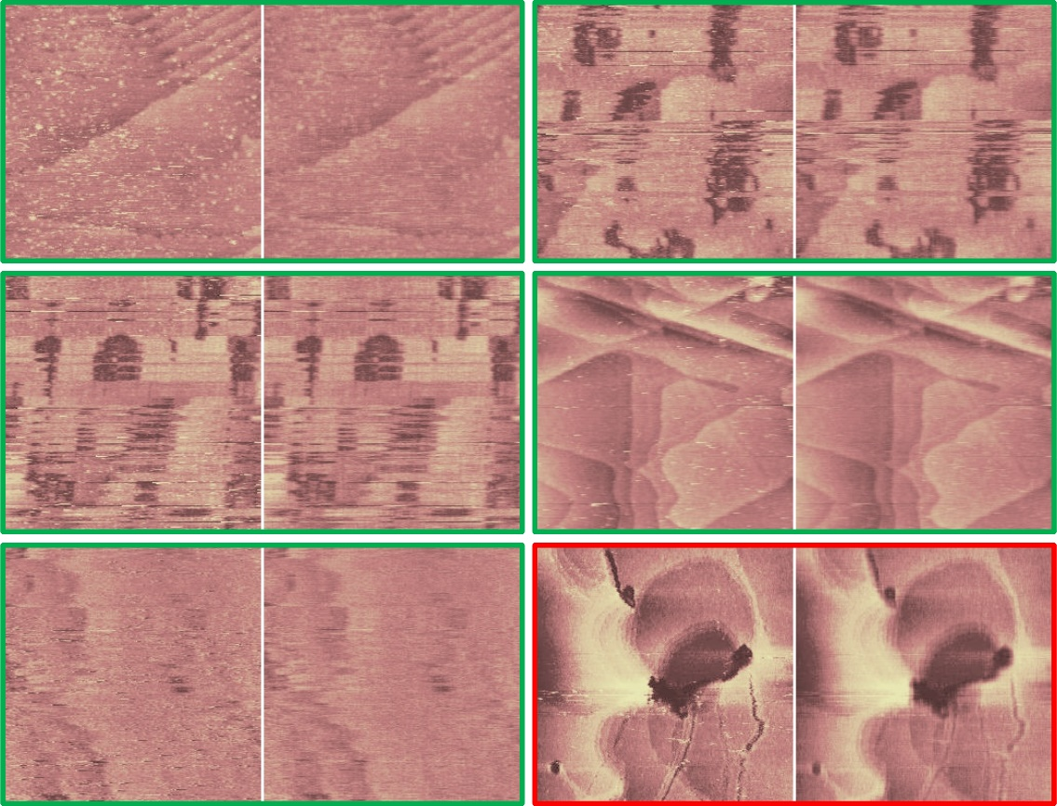

Fig. (A.2): samples in the short stripe restoration algorithm test experiment, the green border represents the restoration is good (defects are restored visually well with little residue and texture fuzzy), the red border represents the restoration is bad (defects partly remain or some side effects are introduced).

(3) samples of periodic noise restoration

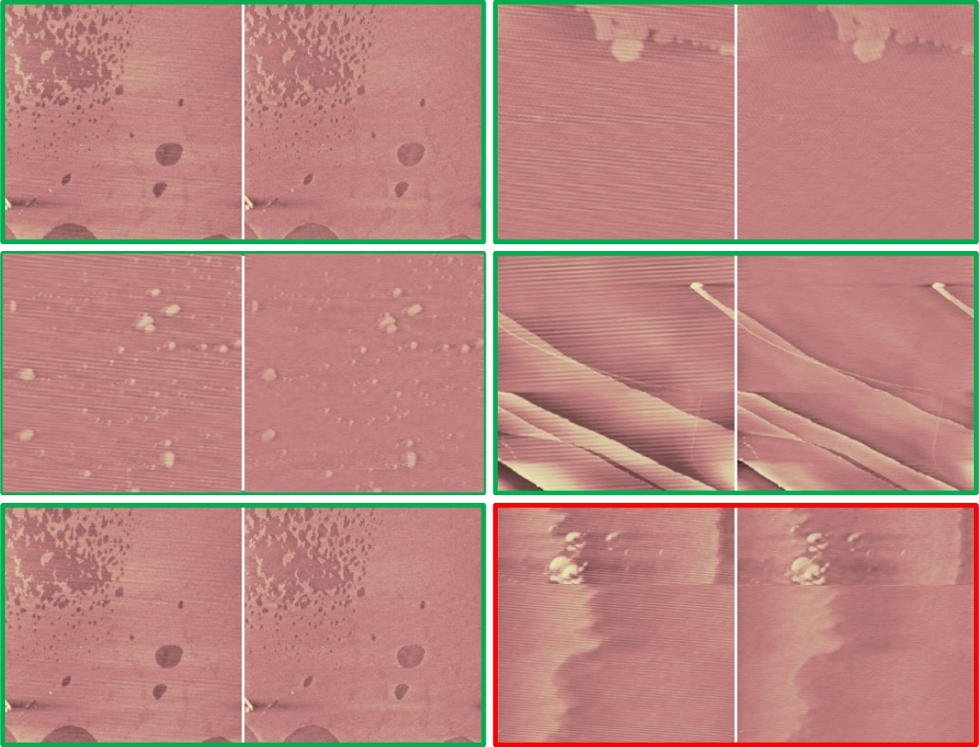

Fig. (A.3): samples in the periodic noise restoration algorithm test experiment, the green border represents the restoration is good (noise are restored visually well with little residue), the red border represents the restoration is bad (defects partly remain or some side effects are introduced).

**part 6: the software combined the processed restoration algorithm**

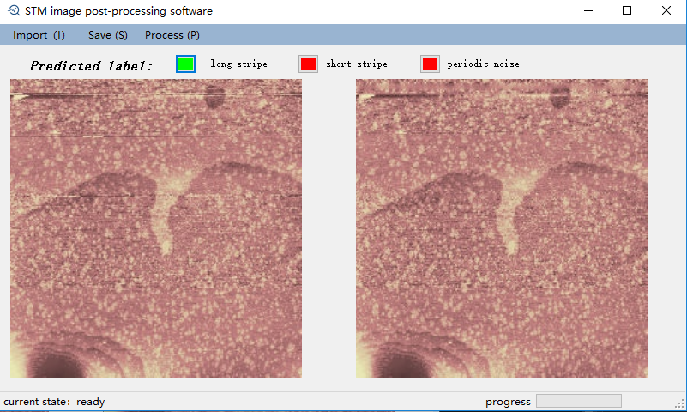

Fig. (A.4):print screen of the image process software